Becoming a bci member

This document comprises of:
- The membership application form
- The membership contract (Membership Code of Practice and Terms of membership)

The membership application form must be completed, signed and returned to the BCI along with required support documents as outlined in the form before membership applications can be accepted.

Once your application has been approved, you will need to sign the membership contract and return to BCI along with proof of payment of your annual fee in order to activate your BCI membership.

application for membership

  - suppliers and manufacturers - OTHER intermediaries

Suppliers and Manufacturers include any organisations that run for profit activity within the cotton supply chain beyond the farm gate and before retail, from buying, selling, and financing to processing. Other intermediaries include spinners, mills, cut and sew, and ginners.

Membership criteria
Membership is open to all organisations. BCI is an inclusive initiative which aims to work with its members and partners to achieve its goal of transforming cotton production worldwide by developing Better Cotton as a sustainable mainstream commodity. Applicants to membership should fulfil the following:
- Your long-term business aspirations support BCI’s mission, aims and strategic principles for Better Cotton (http://bettercotton.org/about-bci/).
- Your organisation is able to demonstrate an existing commitment to good environmental and social standards. Evidence includes either implementing a third party code of conduct / management standard covering both environmental and social practices e.g. SA8000 / ISO14001, or implementing a clients’ codes of practice.
- Your organization is currently not on an internationally recognised Default list, or any advisory list linking you to a defaulting company.
- Your organisation is a legal entity, or a group of legal entities.
- If your organisation forms part of a group, the entire group of companies needs to become a member of BCI. BCI does not accept applications from single entities forming part of larger groups.
- If you run integrated operations including several processing steps, your membership will be categorised according to the highest value activity exercised in terms of annual turnover.
- Should your organisation pose a reputational risk to BCI through past or present activities, it will not be considered for membership.
- An organisation applying for membership should have a minimum of 1 year’s existence.
- If your organisation is currently in arbitration as a result of contract fulfilment issues your membership application will be placed on hold until the dispute is settled. BCI reserves the right to protect and safeguard itself against risks to BCI’s integrity and credibility.

Companies not meeting one or more of the membership criteria listed above may still apply to the BCI by adding a justification to their application form. The justification addendum will be sent by BCI for completion by applicant after a review of the application form.

- The addendum should clearly state that the applicant understands that its application does not meet one or more of the membership criteria, and that its application requires additional justification to demonstrate that it does not present a credibility risk to the BCI.
- The applicant should list the membership criteria that are not met and seek to justify each one.
- It should add relevant affiliations to industry associations that seek to reassure BCI of its reputation, an example being valid membership to an organisation such as the ICA.
- The document should be maximum 2 A4 pages along with any necessary supporting documents.
- The Leadership Team of the BCI will consider the justification as part of the member approval process, their approval is needed to move to the 3-month member consultation.
- The applicant should agree to share the document if requested by any member as part of the 3-month member consultation process.

Company information
About the organisation
Name of company
Business Registration Reference No.
Address (Headquarters) | Building
 | Street
 | City
 | State
 | Postcode/Zip
 | Country
Telephone
Website

The information you provide below will be shared with our Members and Council as part of the consultation and approval process. Answering fully and factually is important to the success of your application.
Date your organisation was established
Brief description of your company’s key activities
Motivation for joining the BCI (sustainability and business motivation)
What would your organisation like to achieve during your first year as a member?
Do you have any interest in becoming a BCI Implementing Partner (IP)? Note that an IP works with farmers at the local level to implement the BCI system. | YES / NO
Do you implement a client’s code of conduct or certifiable standard (social and environmental) e.g. FLA - ETI - SA8000 / ISO14001
Do you work with or purchase any form of non-conventional cotton e.g. Organic, Fairtrade, Cotton Made in Africa, other

Data Protection
By becoming a BCI Member, you accept that contact names and email addresses may be shared through internal group communication (or other means). For more information, please see the BCI Data Protection Policy.
Members often wish to contact each other outside of BCI. If you do not wish your contact details to be shared, please indicate by ticking the box below.
No, I do not wish mine or my organisations’ contact details to be shared with other members

BCI publishes a Membership list on its website and in some presentations. If you do not wish your organisation to appear in this list, please tick the box below:
No, I do not wish my organisation to appear in the BCI Membership list.

As a member, it is normal for us to display your organisations’ logo and include a link to your website. If you do not wish this, please tick the boxes below.
No, I do not want BCI to link to my organisation’s website
No, I do not want BCI to make use of my organisation’s logo

Primary contact
The primary contact nominated should be the person within your organisation who will act as the organisations’ day-to-day representative with BCI. All communications from BCI to your organisations will be directed to the primary contact.
Name | First name | Last name
Position within organisation
Email
Skype username (optional)
Telephone | Country Code | Number

Secondary contact
The application should also be endorsed and signed by a senior member of the organisation who will take responsibility for ensuring that the organisation follows the obligations laid out in the BCI Principles of Participation. You may nominate this senior member as the secondary representative to this function. The secondary contact may be copied into communications but will not be the first point of contact.

Name | First name | Last name
Position within organisation
Email
Skype username (optional)
Telephone | Country Code | Number

Invoicing address
Please supply details to be used for invoicing purposes. Also, please state if your organization requires any specific information in order to process an invoice (such as Purchase Order numbers).
Contact name for invoices |  | First name | Last name
Email
Telephone |  | Country Code | Number
Fax |  | Country Code | Number
Address  (if different to HQ) | Building
 | Street
 | City
 | State
 | Postcode / Zip
 | Country
Any additional information required for invoices

Membership Level
Applicants can choose to join BCI at a level that suits their ambition, capacity and interest. For suppliers and manufacturers, this means that you can choose between Basic and Registered membership.

Basic Membership
Basic membership means you can be part of the initiative while you learn about what it means to market, buy and sell Better Cotton. This type of membership is great for those organisations that are not yet ready to become fully active, or simply want to support BCI in a more hands-off way.

Registered Membership
Registered membership is for those organisations that want to be active players in the Better Cotton Supply Chain. Not only do registered members receive training on how Better Cotton can be more efficiently bought, sold, managed and marketed – BCI will also actively promote your organisation as a supplier who has chosen to become a BCI registered supplier. By choosing this level of membership, your organisation will receive a higher degree of commercial visibility, as well as formal recognition and endorsement by the BCI for the active role played in taking the BCI agenda forward.
Registered suppliers:
- Are trained in how to manage Better Cotton and have free access to the Traceability System for Better Cotton
- Are attractive to BCI’s brand and retailers because they are officially recognised as trained BCI suppliers
- Have a higher profile and visibility on BCI’s website, and are issued a proof of registration
- Are recognised as front-runner suppliers who play a key role in making the supply chain work.
- Benefit from BCI’s investment in the supply chain, and have access to BCI support from teams in direct countries
To become a registered Supplier, participation in an annual training session is required. The training covers key aspects of how to participate in the Better Cotton supply chain, and takes place once a quarter in various regions across the world, including China, India and Pakistan. Face to face events are complemented by webinars.
Steps to become a registered BCI supplier:
- Complete the application form. Submit with relevant documents.
- Sign up for training to guarantee your place at the next training workshop.
- Once your membership is approved, an invoice will be sent by BCI.
- Settle the payment and send BCI a remittance copy to activate your membership.
- Participate in the training.
- Appear in the BCI listing as a BCI registered supplier.
Members have 3 months from the point of renewal to undertake training.
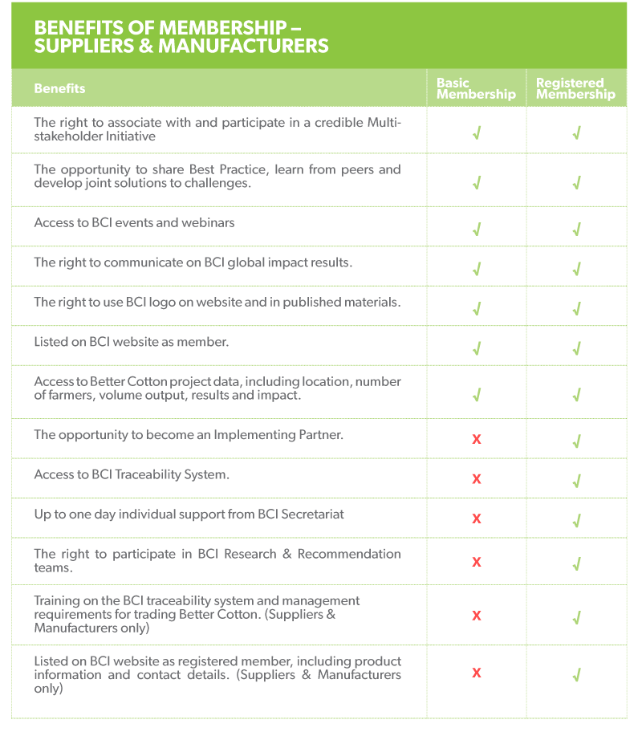
Type of membership
(please choose only one):
Basic membership |  |  | Registered membership

Membership fees
All members must pay a membership fee, on an annual basis, in accordance with the BCI membership fee structure. For Suppliers and Manufacturers, annual membership fees are calculated according to annual company turnover based on all cotton operations only.
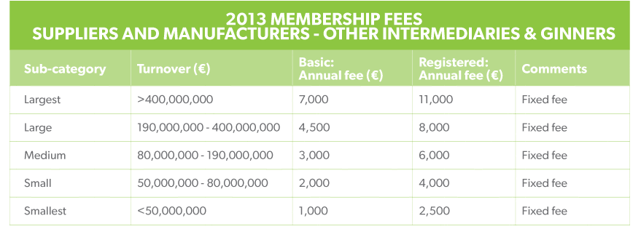

Fee payable :

Please note: you will need to provide evidence of turnover (see below Check list)

Check list
Together with this application form, please make sure you submit the following:

- A copy of your company registration certificate.
This document will typically be a copy of your company’s legal registration with the local administrative authorities. If you are applying as a group which is not a legally registered entity, the certificate of incorporation of each of the companies within the group must be submitted.

- Annual audited report or financial results
The document should clearly show your organisations’ annual turnover (based on all cotton activities). This information will be treated as strictly confidential, and will not be shared with outside parties.

- A signed copy of the BCI Code of Practice
Once your membership is approved, please send us a signed copy of the Code of Practice included in the membership contract below. This, together with your proof of payment, will activate your membership.

Signature
With my signature, ___________________________(entity name) is applying for membership to the Better Cotton Initiative. I confirm that I have the legal mandate officially to act on behalf of my organisation.
With the signature below, ___________________________ acknowledges and accepts the attached BCI Code of Conduct, the BCI Terms of membership, the BCI fee structure, and the BCI Statutes, the BCI Anti-trust Policy and the Data Protection Policy, as well as the resulting rights and obligations.
I declare that all information provided is, to the best of my knowledge, comprehensive and correct.

Date of signature:
Applicant’s signature:
Title:

Membership Code of Practice
  - what we commit to as a member

BCI exists to make global cotton production better for the people who produce it, better for the environment it grows in and better for the sector’s future. BCI works with a diverse range of stakeholders to promote measurable and continuing improvements for the environment, farming communities and the economies of cotton-producing areas. BCI aims to transform cotton production worldwide by developing better cotton as a sustainable mainstream commodity.

As a BCI member, you commit to supporting this mission. You understand and meet this Code of Practice in all your dealings as an organisation. The Code of Practice forms one part of the BCI Principles of Participation, with other components being specific agreements for Traceability System users and Implementing Partners. Breaches of the Code of Practice may lead to a termination of membership as specified in the BCI Statutes.

Commitment and Conduct

The Better Cotton Initiative (BCI) is focused on effecting change, and credibility is crucial to mainstreaming Better Cotton successfully. BCI and its members strive to act with integrity at all times. In practice this means:

- Members commit themselves to the mission, specific aims and strategic principles of the BCI.

Members promote and communicate this commitment throughout their own organisation and to external partners.

Members act responsibly and are transparent in their engagement with BCI.

Members meet the BCI communication rules and do not make any misleading or unsubstantiated claims about the production, procurement or use of Better Cotton, nor about the impact associated with Better Cotton. External communications are evidence-based and consistent.

Collaboration and Promotion

BCI is a multi-stakeholder initiative that promotes collaboration. BCI and its members welcome constructive feedback and aspire to be innovative.
- Members actively share their knowledge and expertise with BCI and other members.
- BCI complements, rather than competes with, other established initiatives. It works alongside such approaches to increase the amount of cotton produced in a more environmentally and socially sustainable way. Members commit to supporting this collaborative approach.

Ensuring continued credibility of the initiative

Credibility and the multi-stakeholder nature of the initiative are crucial to BCI and its members.

Members help BCI monitor for false claims and other risks to BCI’s integrity and credibility.

All members contribute to the continuous improvement of the standard and its system.

Members demonstrate continuous improvement, and report back to BCI on progress annually. BCI reserves the right to monitor claims made in these reports.

Retailers and Brands support farmers and field activities by providing investment contributions on an annual basis.

Commercial commitment
Demand for Better Cotton is key to funding and influence. BCI and its members aim to improve the flow of, and commitment to Better Cotton throughout the supply chain. BCI does not set a premium and pricing is a function of the market. BCI is firmly based on the traceability of Better Cotton.
- Members adhere strictly to the BCI anti-trust policy, and refrain from any behaviour which can be construed as anti-competitive practice.
- Supply chain members respect contract sanctity and contribute to the building of trust in the supply chain. Members on recognised default lists will be suspended.
- Retailers and Brands work to procure Better Cotton in alignment with a strategy or plan for securing 100% more sustainable cotton.
- Members work with their clients and suppliers to promote Better Cotton and share knowledge.
- Retailers and Brands commit to working with their supply chains to promote trust and respect throughout, and commit to sending strong demand signals for Better Cotton.

I am authorised on behalf of my company and hereby confirm that we understand and will follow this Code of Practice.

________________________ __________________________________

Place and date Name of Organisation

_______________________

Title

_______________________

Signature

_______________________ __________________________________

Name in printed letters Organisation stamp

Please sign and submit only this page to the BCI Secretariat.

All members have the responsibility to inform their employees about the content of this Code of Practice and secure their compliance.

BCI is committed to continuously reviewing and updating its policies and procedures, therefore this Code of Practice can be subject to modification. Partners and members are responsible for keeping themselves informed of the contents of such documents.

If you, your employees, or any other representatives of your company have questions concerning the meaning or application of the BCI’s Member Code of Practice, please contact membership@bettercotton.org

TERMS OF MEMBERSHIP

Members commit to a three-year membership period, renewable annually upon fee payment
Members wishing to terminate their membership shall give six months’ advance notice in writing by emailing membership@bettercotton.org. Fees already paid for current membership year are not refundable.

Terms of Payment
  - Membership fees are payable on an annual basis.
  - Invoices will be sent electronically by email by default and as hard copy by post upon request only.
  - Invoices will be considered as received on the next business day following the day the documents were emailed.
  - Membership fee invoices are payable within 30 days of receipt.
  - After 30 days a reminder will be sent by the BCI Secretariat. Fee payments will be considered late if received after 30 days of receipt of the invoice. An interest of 1.5 % of the initial amount invoiced will be payable for each month that payment is overdue.
  - Failure to pay membership fees for 5 months or longer may result in suspension and/ or termination of membership.
  - Fees are reviewed annually.

Adherence to the Better Cotton Initiative Code of Practice

The adherence of members to the Better Cotton Initiative Code of Practice is fundamental to the integrity, credibility and success of Better Cotton.

A violation of the BCI Code of Practice may lead to the suspension and / or termination of membership. A breach of the BCI Code of Practice includes, but is not limited to the following:

1. Practice contradicting the spirit of BCI, its mission, aims and strategic principles
  - Endangering the interests or the reputation of the Better Cotton Initiative and of Better Cotton.
  - False representation of BCI and Better Cotton.
  - Making misleading or unsubstantiated claims about the production, procurement or use of Better Cotton and the impact associated with it.
  - Being listed on a Default list.
  - Behaving in a manner contradictory to the BCI anti-trust guidelines.
  - Taking part in anti-competitive practices.

2. Lack of commitment and engagement
  - Lack of strategy and annual targets to procure Better Cotton (brands and retailers only).
  - Neglect to provide financial capacity investment contributions (brands and retailers only).
  - Lack of engagement:
- No attendance at BCI events/ workshops/webinars.
  - Failure to report back performance to BCI annually according to guidelines provided by BCI.
  - Failure to demonstrate progress through this report (2.4)

Termination of membership
Under the BCI Statutes, a member ceases to be a member of the Association if the member:
- becomes insolvent
- is wound-up or is dissolved
- resigns that membership by written notice to the Council with a notice period of at least six months
- or is expelled from the Association.

The Council may expel a member if it determines that:
- the member no longer meets the definition specified for the member’s membership category
- the member no longer meets the membership criteria
- the member fails to adhere to the BCI Code of Practice or to pay membership fees, on an annual basis, in accordance with the membership fee structure
- the member fails to pay their membership fees on an annual basis, and in accordance with the membership fee structure
- the member is endangering the interests or the reputation of the Association.

In case of expulsion, the Council must give the member at least 30 days written notice of the expulsion, stating the grounds for the expulsion and allowing the member to provide a written submission stating why they should not be expelled, with such submission to be received prior to the proposed date of expulsion. The Council’s decision whether or not to expel a member is final.

